MOROCCO FAMILY GOLF FESTIVAL
9th to 16th October 2010 – MARRAKECH

The MOROCCO GOLF FESTIVAL is an annual golf competition – open to amateur golfers (Senior men, Senior women, men, women, boys & girls). Handicap limits: Men: 28, Ladies/girls 36.
AGGREGATE STABLEFORD TOURNAMENT: Four rounds, best three points totals to count
In addition to competitive golf, there is an exciting programme full of various activities: Cocktails party – City sightseeing tour of Marrakech– Gala Dinners– Accompanying person programme….. This tournament week is great fun and an enjoyable way of making new friends, friendly competition and play on some outstanding golf courses in Morocco

PROGRAMME:

Saturday 9th October 2010:
Flight from London Gatwick to Marrakech (operated by ROYAL AIR MAROC (Flight AT673, depart from London Gatwick North Terminal at 20:30 and arrive to Marrakech at 23:05).
Assistance in Marrakech airport and transfer to the PALM PLAZA HOTEL & SPA 5*****
Check-in and overnight at the hotel
* Please note that flights can be arranged from other airport direct to Marrakech (From Edinburgh, Manchester, East Midlands, London Luton, Bristol) at a supplement.

Sunday 10th October 2010:
Buffet Breakfast at the hotel - transfer to the ROYAL Golf Club
Better-ball pairs: (good way to get people mixing right at the start of the week)
Transfer back to the hotel
Cocktail party at 19:00 in the hotel
Dinner & Overnight in the hotel

Monday 11th October 2010
Buffet Breakfast at the hotel - transfer to the PALMERAIE Golf Club
Individual Stableford Tournament Round 1
Transfer back to the hotel
Dinner & Overnight in the hotel

Tuesday 12th October 2010
Buffet Breakfast at the hotel - transfer to the AMELKIS Golf Club
Individual Stableford Tournament Round 2
Transfer back to the hotel in the hotel, Dinner & overnight
Transfer back to the hotel

Wednesday 13th October 2010
Buffet Breakfast at the hotel – Guided city tour of Marrakech
Transfer back to the hotel - Afternoon at leisure
Dinner & Overnight in the hotel

Thursday 14th October 2010
Buffet Breakfast at the hotel - transfer to the AL MAADEN Golf Club
Individual Stableford Tournament Round 3
Transfer back to the hotel in the hotel
Dinner & Overnight

Friday 15th October 2010
Buffet Breakfast at the hotel - transfer to the AMELKIS Golf Club
Individual Stableford Tournament Round 4 (Final Round)
Transfer back to the hotel in the hotel
Gala Dinner with entertainment & Prizes presentations ceremony
Overnights at the hotel

Saturday 16th October 2010
Buffet Breakfast at the hotel – Morning at leisure
Transfer to Marrakech airport for the return flight to UK – assistance with the check-in formalities
(Flight AT672, Depart from Marrakech at 15:05 and arrive at 19:40)
End of our services

Prices
Golfer: £789 per person (sharing a Twin or Double room)
Non-Golfer: £630 (Sharing a Twin or Double Room)
Single room Supplement: £80 (for 7 Nights)

The price includes:

- Return schedule flight with Royal Air Maroc from London Gatwick to Marrakech (Flights from other UK airports at a supplement)
- Seven (07) Nights accommodation in the PALM PLAZA HOTEL & SPA 5***** in Marrakech
- Daily buffet breakfast
- 5 Rounds of competitive golf and playing on the Royal, Amelkis, Plameraie & Al Maaden Golf Courses
- Cocktail Party
- Gala Dinner with Prizes Presentation
- Five (05) Dinners at the hotel as per the programme
- Half Day guided tour of Marrakech
- Ground transfers & Transportation
- Our Permanent assistance in Marrakech

PRIZES
1st, 2nd & 3rd of each category: senior men, senior women, men, women, boys (under-18 and under-16), girls (under-18 and under-16).

OTHER Flights Options:

From EDINBURGH to MARRAKECH
- Saturday 9th October 2010: RYANAIR Flight No FR6824, Depart from Edinburgh at 14:50 and arrive to Marrakech at 18:10
- Saturday 16th October 2010: RYANAIR Flight No FR6825, Depart from Marrakech at 18:35 & Arrive to Edinburgh at 23:55

From BRISTOL to MARRAKECH
- Saturday 9th October 2010: RYANAIR Flight No FR8218, Depart from Bristol at 15:55 and arrive to Marrakech at 18:30
- Saturday 16th October 2010: RYANAIR Flight No FR8219, Depart from Marrakech at 18:55 & Arrive to Bristol at 23:35

From MANCHESTER to MARRAKECH
- Saturday 9th October 2010: EASYJET Flight No 1893, Depart from Manchester at 14:35 and arrive to Marrakech at 17:40
- Saturday 16th October 2010: EASYJET Flight No 1894, Depart from Marrakech at 18:10 & Arrive to Manchester at 22:55

From London Gatwick to MARRAKECH
- Saturday 9th October 2010:
- EASYJET Flight No 8895, Depart from Gatwick at 12:25 and arrive to Marrakech at 15:05
- EASYJET Flight No 8897, Depart from Gatwick at 15:35 and arrive to Marrakech at 18:15

- Saturday 16th October 2010:
- EASYJET Flight No 8896, Depart from Marrakech at 15:40 & Arrive to Gatwick at 20:10
- EASYJET Flight No 8898, Depart from Marrakech at 18:50 & Arrive to Gatwick at 23:20

MARRAKECH
The Golf Holiday to remember in a city you will never forget
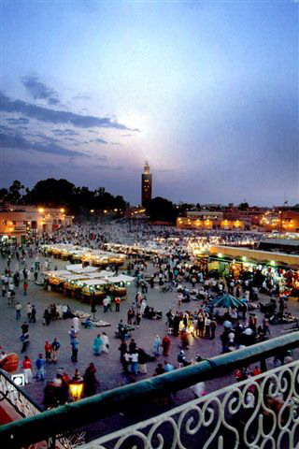
Lying at the foot of the Atlas Mountains, nested in the midst of a palm-grove is the red pearl, Marrakech! More than an Imperial city, Marrakech legitimately boasts the sumptuous relics of its glorious past: palaces, tombs, gardens and minarets compete with each other for the pleasure of the visitor. A most lively city, a city of thousand and one perfumes, colours and melodies where life is a continuous show, climaxing at the natural theatre of Djemaa El Fna Square where magicians, acrobats, storytellers, and fortune-tellers gather to entertain you. Extending north from the square is the medina within which lies the imperial heritage of Marrakech. Wandering the SOUKS in the Medina is like travelling back in time, some shops glittering with jewellery, some festooned with richly coloured carpets and all around you the sounds of bargaining for that all important “best price”!
A dry and healthy climate adds to the pleasures of visits and excursions, making it possible to practice all kinds of open-air sports.

Palm Plaza Hotel & Spa 5*****
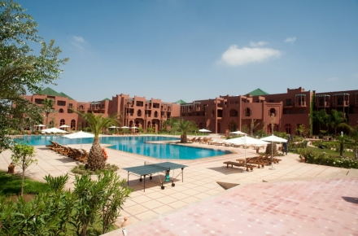
Located in Agdal, a new residential district, Palm Plaza Hotel & Spa welcomes you in a luxury setting in the heart of Marrakech, 10 minutes from the airport and 8 minutes from Djamaâ Elfna Square. Palm Plaza Hotel features comfortable rooms and suites. Savour exotic dishes in the hotel’s restaurants.
Have a snack in the pool bar and in the evening, a quiet time in the piano bar or an exciting night in the night club. Enjoy a relaxing stay in Palm Plaza Hotel. The spa features a heated indoor swimming pool, a sauna, a Hammam and a gym
Palm Plaza Hotel & SPA has 230 rooms, including 151 Twin, 52 Double, 2 rooms for disabled persons, 6 junior suites, 20 senior suites and a royal suite.
Houses of Palm Plaza Hotel & Spa are equipped by air conditioning, heating, Internet access and free Wi-Fi, satellite TV, safe, mini bar, telephone, hair dryer, voice mail and automatic alarm

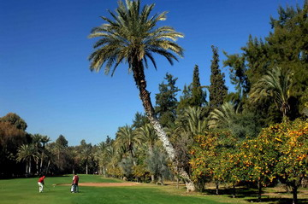
ROYAL Golf Club - Marrakech
The Marrakech Royal Golf course is one of the oldest golf courses in Morocco, It is a course of extreme beauty - Winston Churchill, David Lloyd George and General Eisenhower have played here. The course is fairly narrow and winds through a profusion of cypress, eucalyptus, palm, olive, orange and apricot trees. It is a course of extreme beauty. It is located at the feet of the Atlas Mountains. The background of Atlas Mountains to this course will offer you a test of your shot making skills

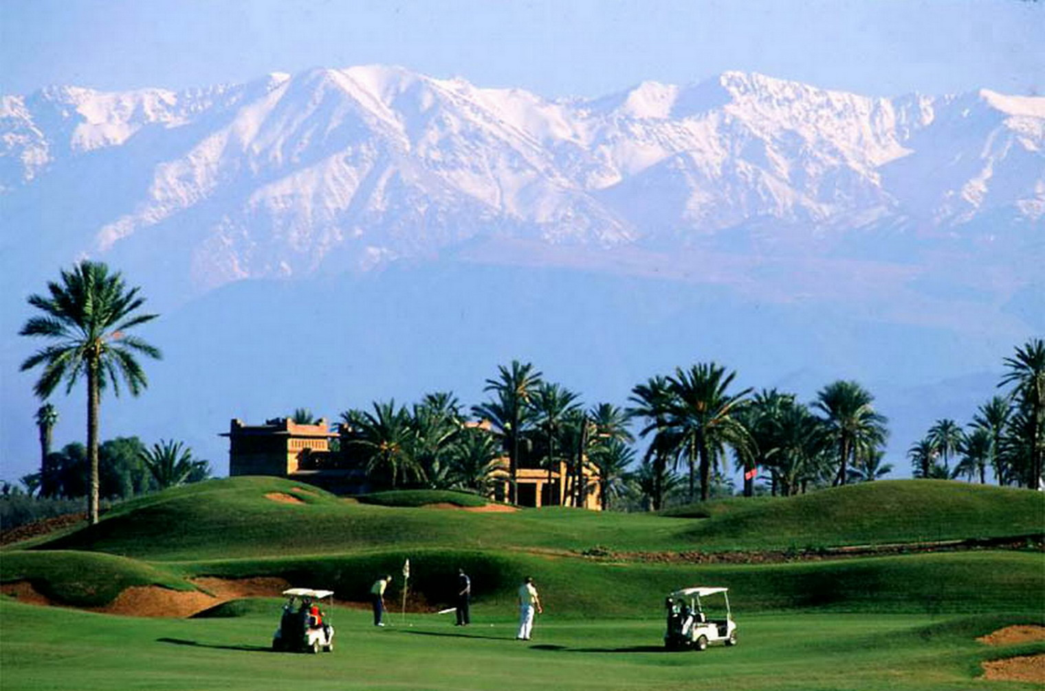
AMELKIS Golf Club
Set in a beautiful landscape – near the Royal Golf Club – and with wonderful views of the snow-covered Atlas Mountains. The club house, an ochre coloured traditional Kasbah style overlooks the links and creates a muted atmosphere ideally suited for relaxing after a game.
This course is testing for any golf with a number of water features and bunkers but set beautifully amongst palm groves and Moroccan architecture. The course has integrated the “Khettaras” - An 11th Century irrigation system built by the Almoravides Dynasty

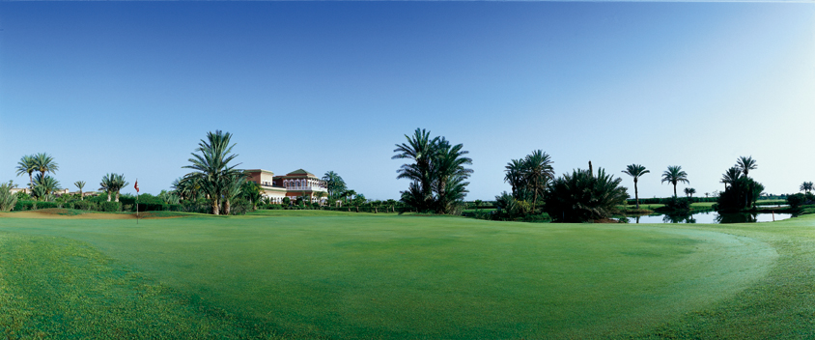
PALMERAIE Golf Club
When the international master Robert Trent Jones Sr. was presented with a perpetually limpid sky, the celebrated Palmeraie (Palm Grove) at Marrakech and the majestic Atlas mountains, he created an 18- holes masterpiece: The Palmeraie Golf Course. The golf course is dotted with 7 lakes and covers, beautiful fairways among palm trees with an unforgettable panorama of the high Atlas Mountains. The club house is sumptuous and offers many facilities

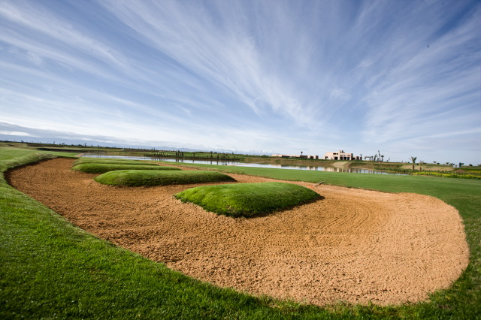
AL MAADEN Golf
Al Maaden is situated near the fascinating historical and cultural center of Marrakech, with the majestic Atlas Mountains as a backdrop. This 18-ho le golf course is designed by Kyle Phillips
The golf course has been designed in grand rolling terrain, placed at the foot hills of the nearby Atlas Mountains. Strategically placed bunkers give players multiple lines of play from the tee and tightly cut spill off areas around the greens gather errant shots, providing a variety of exiting recovery opportunities.
Keeping with the traditions of golf, AI Maaden is designed as a walker friendly course, with a surrounding designed landscape and geometric water features that give a feeling of playing through a Moroccan garden

